Binary Search Tree

* Different structure for that information that on average will be much faster to search

Using the structure of natural recursion (using first of list)

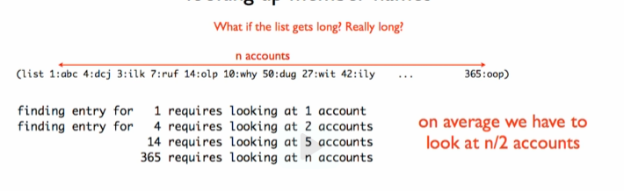

Sorting ALONE doesn’t help too! Because we always check the first element of the list first

Other possible structure

1. Sort the list



1. Take the middle



1. Split around the middle

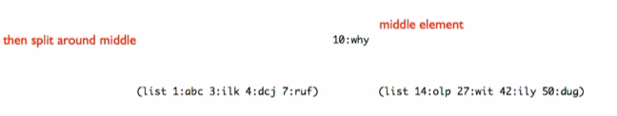

Before middle:  - all less than the middle

After middle: 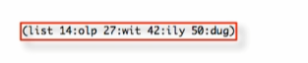 - all greater than the middle

1. Again split around the middle

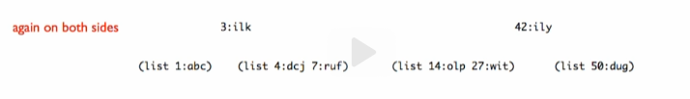

1. And again

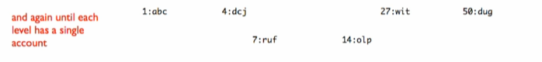

1. Draw the lines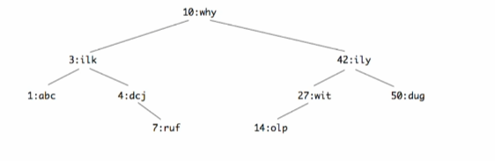

This is called a Binary Search Tree

Binary Search Tree

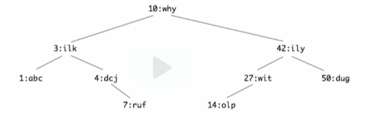

At each level:

* All accounts in left sub-tree have account number less than the root
* All accounts in right sub-tree have account number greater than root

Every element is called a NODE

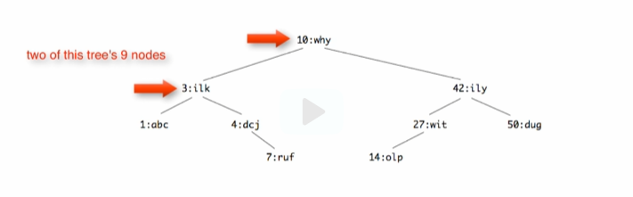

**INVARIANT RULE**

* It’s true over the entire tree!

At each level:

* All accounts in left sub-tree have account number less than the root
* All accounts in right sub-tree have account number greater than root

Each step where we don’t find what we’re looking for, we eliminate about half the tree

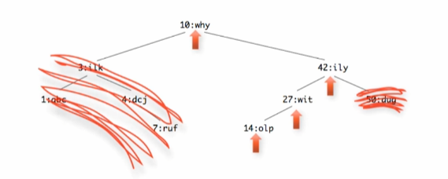

On list: it gets smaller by 1 at each recursive call



On BST: it gets smaller by ½ at each recursive call

